Problem Statement
You are planning a trip to London and have a 2015 weather dataset of ~39 000 observations (TemperatureC, month, hour, Humidity, Pressure, Precip). The yearly mean and SD are not helpful for choosing a month because they mix seasons. The task is to compute variance and standard deviation overall and by month, compare June vs July, identify the coolest and most temperature-stable months, and interpret the results for both a technical analyst and a non-specialist traveller.

Solution Strategy
1. Load data (project.Rda / CSV). 2. Extract TemperatureC → mean, var(), sd(). 3. Filter by month with dplyr::filter (or base subset). 4. group_by(month) + summarise for all 12 months. 5. Alternate pure-base-R paths (tapply / aggregate / split+sapply). 6. Extra practice on rain proportion, humidity, hour-of-day. 7. Monte-Carlo: vary sample size and additive noise; observe SD behaviour. Audience adaptation drawn from the attached “What to Consider When Considering the Audience” and “Audience and Situation Analysis” PDFs.

Solution
Key numbers: Whole-year mean ≈ 10.29 °C, sample variance ≈ 41.61, SD ≈ 6.45 °C. June mean 17.90 °C (SD 3.28), July mean 17.15 °C (SD 3.33). Coolest month = December (≈ 2.18 °C); most stable = June (lowest monthly SD). Monthly SDs cluster tightly around 3.3 °C once seasonality is removed.
Flowchart of the analysis path:
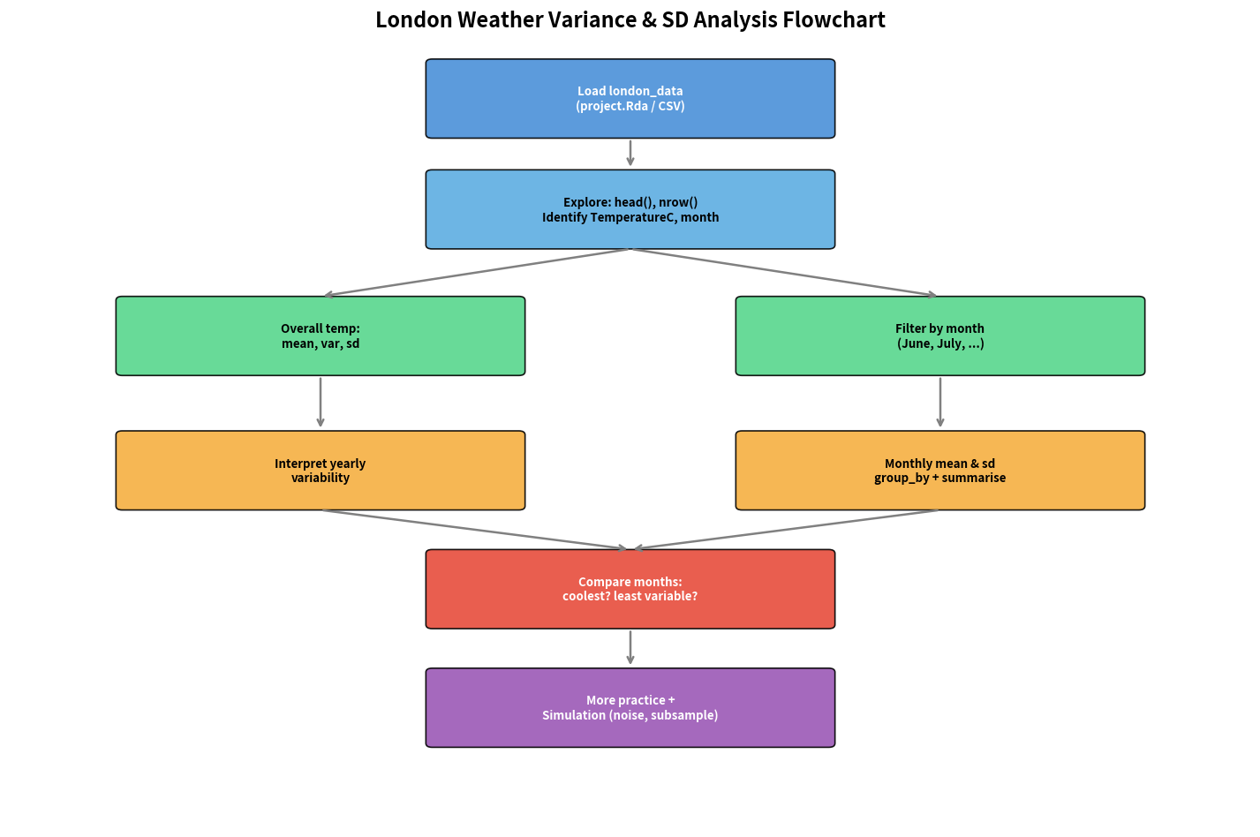
Monthly mean & SD (left) and temperature histogram (right):
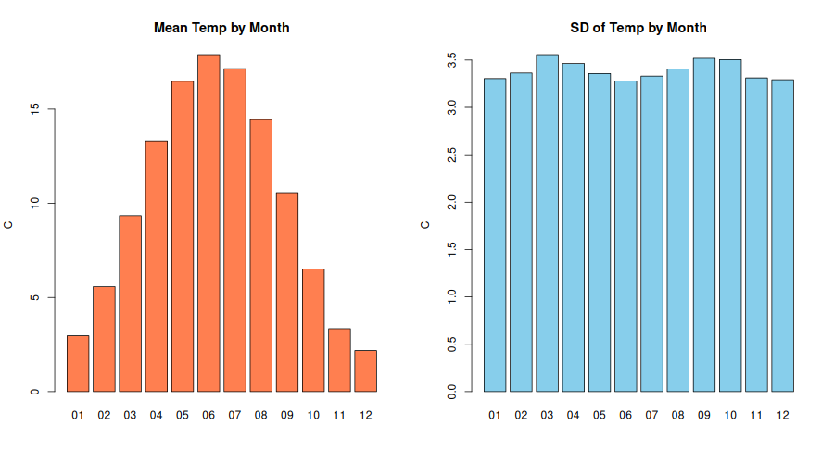
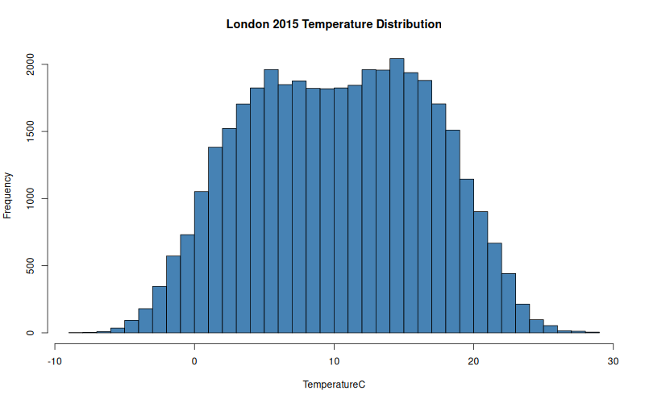

Key Takeaways
• Year-level SD is dominated by seasonality; always disaggregate by month (or season) for trip planning.
• June and July are both warm and equally stable (SD ≈ 3.3 °C); choice can be driven by other factors (rain, events).
• dplyr and pure base-R (tapply/aggregate) produce identical monthly statistics — choose the style that matches your audience’s code literacy.
• Simulation confirms SD estimates stabilise with a few thousand observations; additive noise inflates observed SD as expected from variance addition.
• Audience adaptation: give analysts exact numbers + alternate code; give travellers a plain-language recommendation focused on reliability rather than technical definitions of variance.

